**Answer to the Question no - 03:**

The detailed outputs for different data sizes are shown below:

1. **Size: 128**

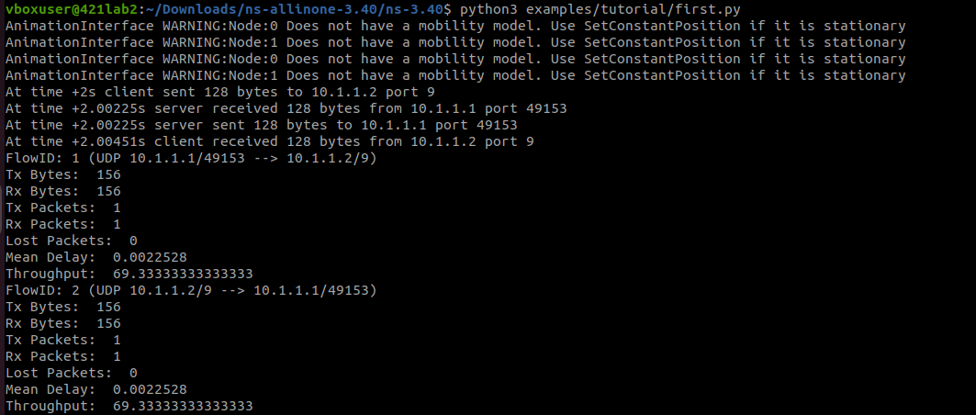

1. **Size: 256**

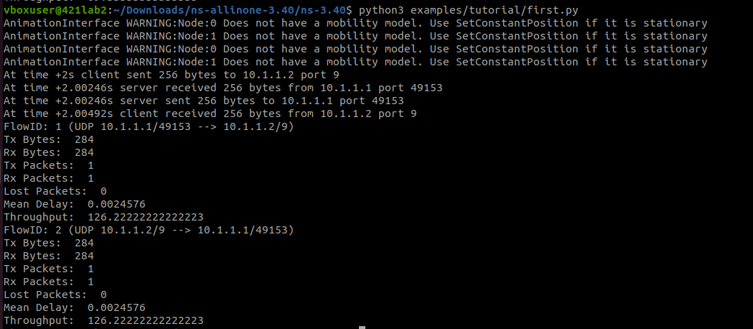

1. **Size: 512**

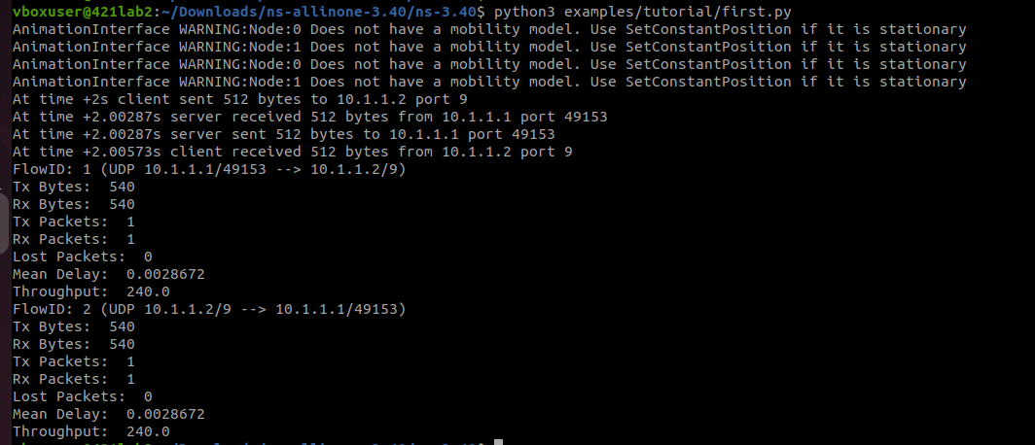

1. **Size: 1024**

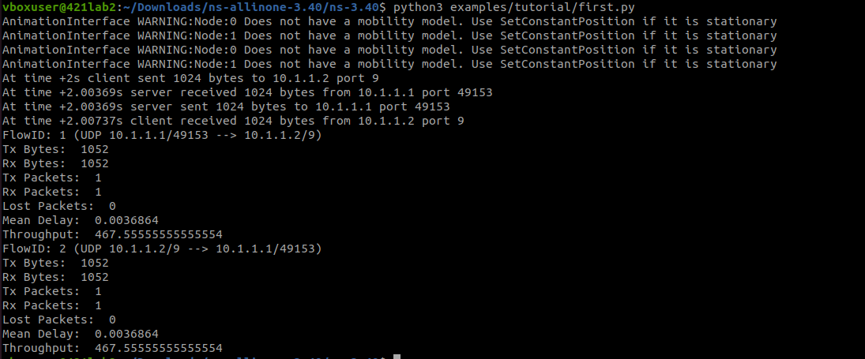

1. **Size: 2048**

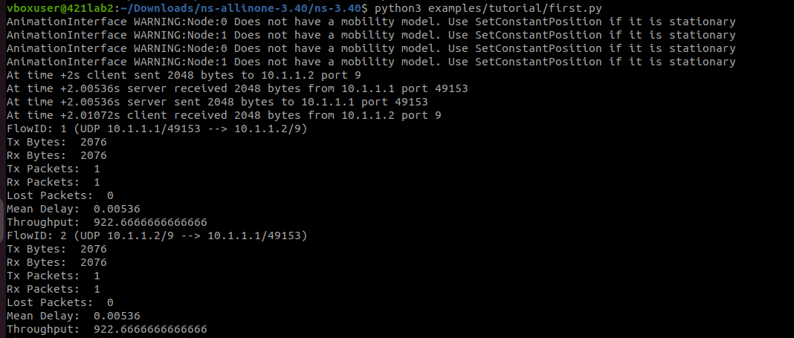

**The throughput vs data size graph:**

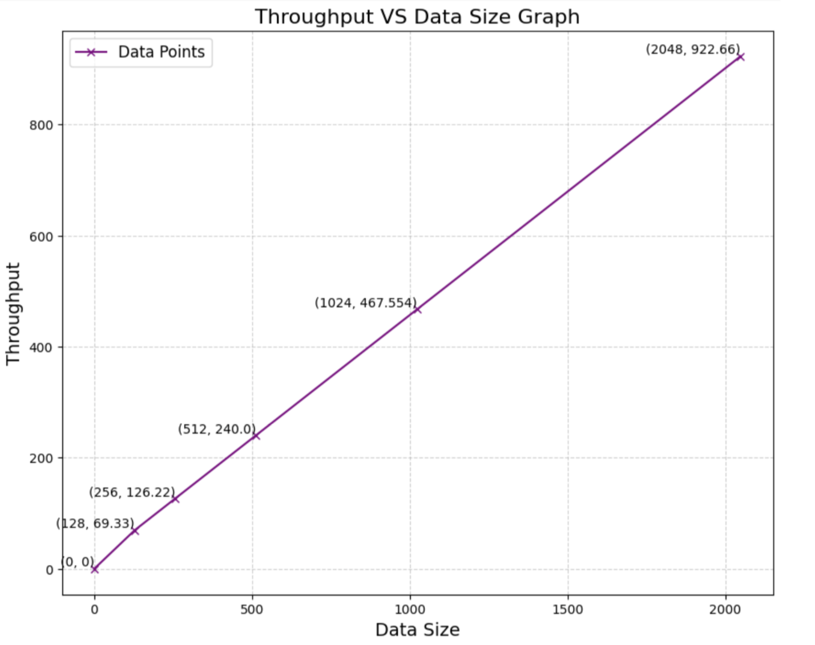

The graph showcases a linear relationship between the throughputs and data sizes, which indicates that throughput scales proportionally as the data size increases. Moreover, larger data sizes result in higher throughput.